Software Requirements Specifications (SRS)
for Online Bookstore

Vignesh M (71382002138)
CSE ‘C’ 3rd year

Table of contents
- Introduction
- Scope
- Product functional requirements
- External interface requirements
- Software system attributes
- UML Diagrams
- Screen Shots

Introduction:
The purpose of this Software Requirements Specifications (SRS) is to fully document the specifications and requirements for the Online Bookstore. The audience of this SRS will be the users who want the software to be built and the technical professionals developing the software

Scope:
The objective of this project is to create and implement a website for the BSU bookstore. The website will be used primarily by students. The website will allow users to create and maintain individual secured accounts, search the Bookstore database for textbooks, and make secured online credit card purchases.Users will also be able to contact site administrators. The website makes purchasing textbooks quicker, easier, and more convenient.

Product Functions Requirements:
The following list of function descriptions explains the major features of the Online Bookstore

- Account Registration:
The registration function shall allow users to create secure accounts.
The account will track the user’s name, address, credit card information,username and password.
Rationale: This provides security to the account member by setting up an account that is password protected. This also offers convenience so the user only has to enter the information listed above once and then it is stored in the account.

- Account Login:
The account login function shall allow account members to enter
their username and password. Once verified, users will be able to
access account history, purchase books online, and update their account information.
Rationale: This provides a method by which the user can access the restricted operations.

- Search:
The search function shall offer users the ability to search for books
by title, author, subject, course number, professor, or ISBN number.
Rationale: This offers a way to find a book if the user does not have
complete information about it. It also provides price and availability
information.

- Add to Shopping Cart:
The add to shopping cart function shall allow users to temporarily
save books in a list that are being considered for purchase.
Rationale: This offers convenience to the user by storing the books of
interest online and allowing continuation of shopping.

- Delete from Shopping Cart:
The delete from shopping cart function shall remove any unwanted
books from the cart.
Rationale: This allows users to change their orders easily and not be
forced to purchase books that are no longer of interest

- Reserve:
The reserve function shall hold books for up to 7 days that will be
purchased and picked up at the bookstore.
Rationale: This offers convenience to the user by allowing them to make sure a book will be in stock for immediate pickup. This also offers convenience for those who are unable or unwilling to give credit card nformation over the Internet.

- Checkout:
The checkout function shall allow account members to purchase
books online securely.
Rationale: This offers easy purchasing and added assurance with a
confirmation number.

- Contact Us:
The contact us function shall give users the store address, telephone
number, email address, and its location on a map.
SRS for Online Bookstore!

Rationale: This helps the user gain trust in the bookstore by showing how easy it is to have person-to-person contact with a Bookstore employe

- Update Account Information:
The update account information function shall give account
members access to edit their stored information.
Rationale: This offers convenience to the account members by allowing them to make changes to account information immediately.

- View Shipping Status:
The view shipping status function shall allow account members to
enter their confirmation number for a purchase and then view the
status of shipment.
Rationale: This offers convenience to account members so they can find out when they should expect shipment.

- View Account Purchase History:
The view account purchase history function shall allow account
members to see previous purchases made under their username.
Rationale: This offers convenience to account members by allowing them
to easily view purchase history.

- Account Logout:
The account logout function shall allow account members to exit their account for security purposes.
Rationale: This allows account members to exit their accounts, and prevent others from accessing it.

- Help:
The help function shall give the user an overview of how to use the
different functions listed above.
Rationale: This allows the user to get answers to immediate questions on using the website.

External Interface Requirements:

- System Interface:

The system will interface with the following two systems:

1. A credit card processing system: The system will access the credit card processing system via its web services API.
2. The Bookstore Inventory database: The system will interact with the inventory database via an ODBC connection.

- User Interfaces:

The system will provide the ability for students and faculty to access the BSU Online Bookstore via the Internet. There will be three different user interfaces that will accompany this website: one for the students, the faculty, and the administrators.

Software System Attributes:

- Reliability:

The average time to failure shall be 30 days. In the event that a server does crash, a backup server will be up and running within the hour.

- Availability:

The BSU Online Bookstore shall be available to users 24 hours a day, 7 days a week, with the exception of being down for maintenance no more than one hour a week. If the system crashes, it should be back up within one hour.

- Security

Users will be able to access only their own personal information and not that of other users. Purchases will be handled through a secure server to ensure the protection of user’s credit card and personal information.

- Maintainability:

Any updates or defect fixes shall be able to be made on server-side computers only without any patches required by the user. 3.6.5. Portability Nothing required

UML Diagrams:
Class Diagram

Class diagram is a collection of static elements such as classes and their relationships connected as a graph to each other.

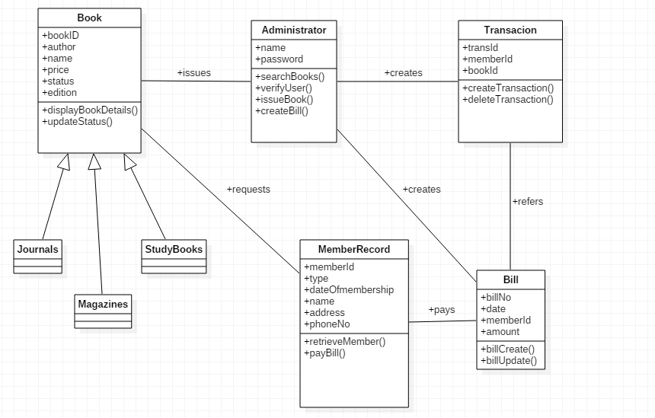

Usecase Diagram

Use case diagram is a diagram that shows the interaction between user and system to capture the user’s goals.

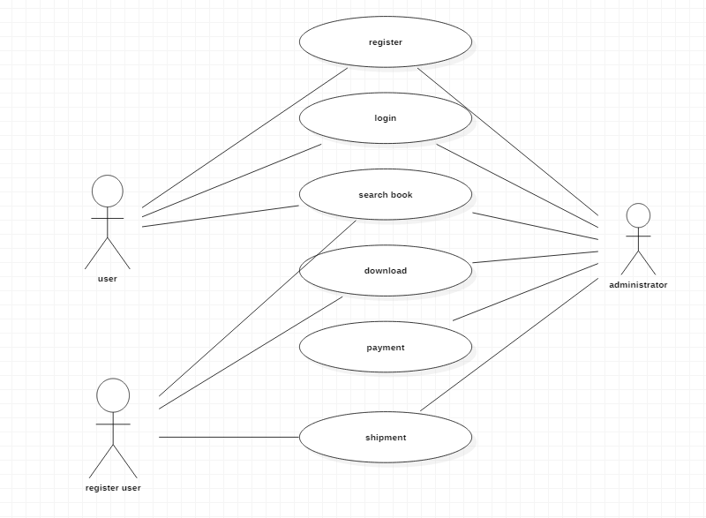

Sequence Diagram

A sequence diagram shows the process interactions arranged in time sequence. It depicts the process involved and the sequence of messages exchanged between the processes needed to carry out the functionality.

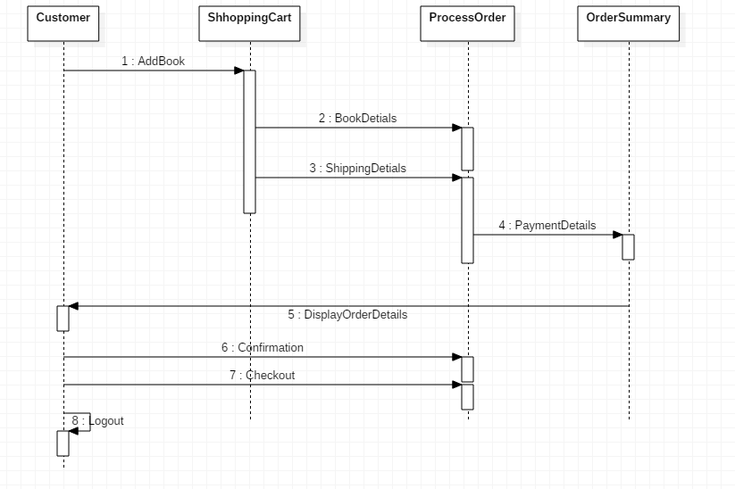

Statechart Diagram

Statechart diagram is used to describe the states of different objects in its life cycle.

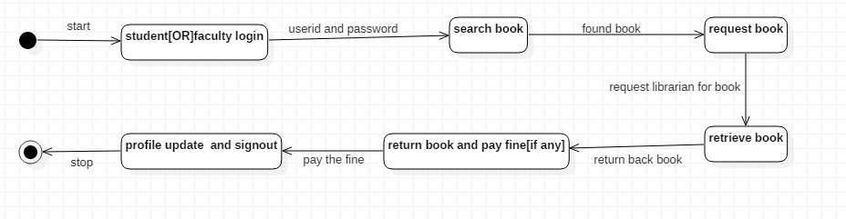

Activity Diagram

Activity diagrams are graphical representation of workflows of stepwise activities and actions with support pf choices, iteration and concurrency.

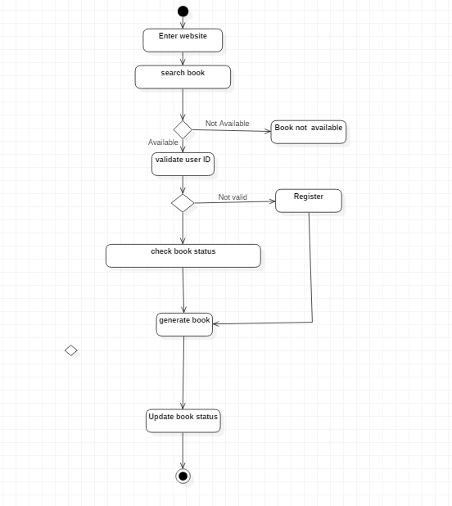
Component Diagram

A component diagram depicts how components are wired together to form larger components or software systems. They are used to illustrate the structure of arbitrary complex systems.
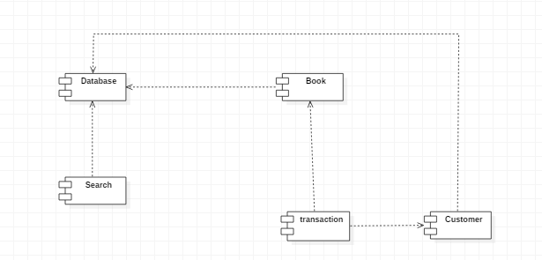
Deployment Diagram

A deployment diagram models the physical deployment of artifacts on nodes.
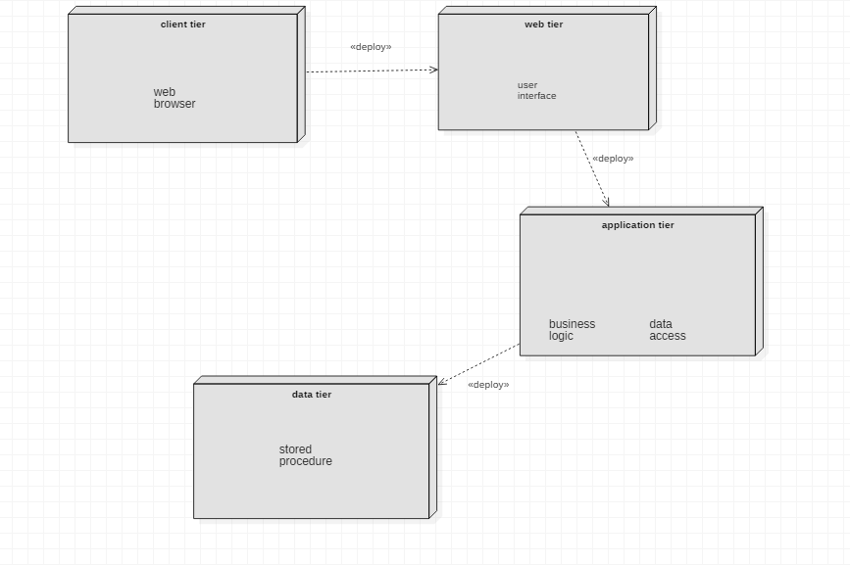

Package Diagram

A package diagram depicts the dependencies between the packages that make up a model.

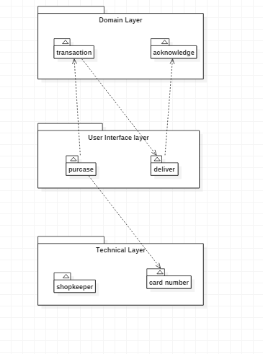

Communication Diagram

A communication diagram shows the interaction between elements at run-time in much the same manner as a Sequence diagram.

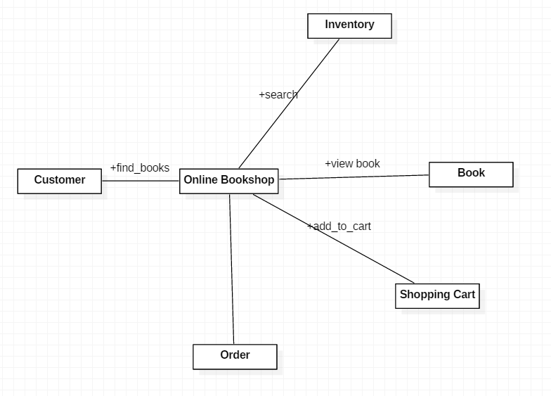

Screen Shots:

